PIZZA SALES SQL QUERIES

-- KPI's Requirement

-- Total Revenue: The sum of the total price of all pizza orders

SELECT SUM(total_price) AS Total_Revenue FROM pizza_sales



-- Average Order by Value: The average amount spent per order, calculated by dividing the total revenue by the total number of orders

SELECT SUM(total_price) / COUNT(DISTINCT order_id) AS Avg_Order_Value FROM pizza_sales



-- Total Pizzas Sold: The sum of the quantities of all pizzas sold

SELECT SUM(quantity) AS Total_Pizza_Sold FROM pizza_sales



-- Total Orders: The total number of orders placed

SELECT COUNT(DISTINCT order_id) AS Total_orders FROM pizza_sales



-- Average Pizzas per Order: The average number of pizzas sold per order, calculated by dividing the total number of pizzas sold by the total number of orders

SELECT CAST(CAST(SUM(quantity) AS DECIMAL(10,2)) /

CAST(COUNT(DISTINCT order_id) AS DECIMAL(10,2))

AS DECIMAL(10,2))

AS Avg_Pizza_Order

FROM pizza_sales



--==========================

-- CHARTS REQUIREMENT

-- Daily Trend for Total Orders

SELECT DATENAME(DW, order_date) AS order_day,

COUNT(DISTINCT order_id) AS Total_orders

FROM pizza_sales

GROUP BY DATENAME(DW, order_date)

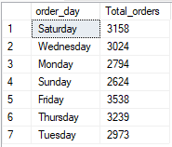

-- Monthly Trend for Total Orders

SELECT DATENAME(MONTH, order_date) AS Month_Name,

COUNT(DISTINCT order_id) AS Total_orders

FROM pizza_sales

GROUP BY DATENAME(MONTH, order_date)

ORDER BY Total_orders DESC

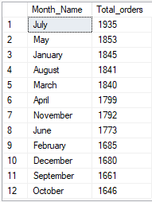

-- Percentage of Sales by Pizza Category

SELECT pizza_category,

SUM(total_price) AS total_sales,

SUM(total_price) * 100 / (SELECT sum(total_price)

FROM pizza_sales) AS perc_of_sales

FROM pizza_sales

GROUP BY pizza_category

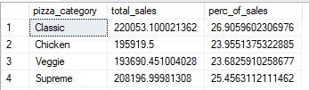

-- filtering for january

SELECT pizza_category,

SUM(total_price) AS total_sales,

SUM(total_price) * 100 / (SELECT sum(total_price)

FROM pizza_sales

WHERE MONTH(order_date) = 1) AS perc_of_sales

FROM pizza_sales

WHERE MONTH(order_date) = 1 -- (filtering for january)

GROUP BY pizza_category

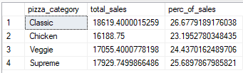

-- Percentage of Sales by Pizza Size

SELECT pizza_size,

SUM(total_price) AS total_sales,

SUM(total_price) * 100 / (SELECT sum(total_price)

FROM pizza_sales) AS perc_of_sales

FROM pizza_sales

GROUP BY pizza_size

ORDER BY perc_of_sales DESC

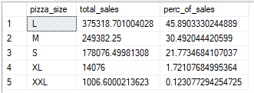

--refining decimals

SELECT pizza_size,

CAST(SUM(total_price) AS decimal(10,2)) AS total_sales,

CAST(SUM(total_price) * 100 / (SELECT sum(total_price)

FROM pizza_sales) AS decimal(10,2)) AS perc_of_sales

FROM pizza_sales

GROUP BY pizza_size

ORDER BY perc_of_sales DESC

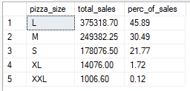

--for 1st quarter

SELECT pizza_size,

CAST(SUM(total_price) AS decimal(10,2)) AS total_sales,

CAST(SUM(total_price) * 100 / (SELECT sum(total_price)

FROM pizza_sales

WHERE DATEPART(quarter, order_date)=1) AS decimal(10,2)) AS perc_of_sales

FROM pizza_sales

WHERE DATEPART(quarter, order_date) = 1

GROUP BY pizza_size

ORDER BY perc_of_sales DESC

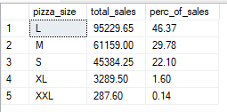

-- Top & Worst 5 Sellers by Revenue, Total Quantity, and Total Orders

SELECT TOP 5 pizza_name,

SUM(total_price) as total_revenue

FROM pizza_sales

GROUP BY pizza_name

ORDER BY total_revenue DESC

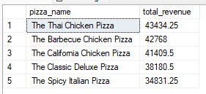

SELECT TOP 5 pizza_name,

SUM(total_price) as total_revenue

FROM pizza_sales

GROUP BY pizza_name

ORDER BY total_revenue ASC

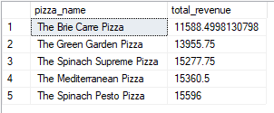

SELECT TOP 5 pizza_name,

SUM(quantity) as total_quantity

FROM pizza_sales

GROUP BY pizza_name

ORDER BY total_quantity DESC

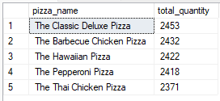

SELECT TOP 5 pizza_name,

SUM(quantity) as total_quantity

FROM pizza_sales

GROUP BY pizza_name

ORDER BY total_quantity ASC

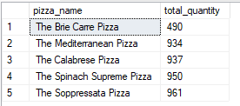

SELECT TOP 5 pizza_name,

COUNT(DISTINCT order_id) as total_orders

FROM pizza_sales

GROUP BY pizza_name

ORDER BY total_orders DESC

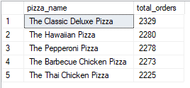

SELECT TOP 5 pizza_name,

COUNT(DISTINCT order_id) as total_orders

FROM pizza_sales

GROUP BY pizza_name

ORDER BY total_orders ASC

